**The Den of Sin’s D&D OSE House Rules v1.1 – Patch Notes**

* Reworked all skills
* Reverted to B/X Saves
* Reworked Death Spiral
* Reworked leveling mechanic

**The Den of Sin’s D&D OSE House Rules v1.1**

# **------------------------------------------CHARACTER CREATION---------------------------------------------**

# Ability Scores

* Roll 4d6, drop lowest. Assign the score to the stat of your choice. No other modifications allowed. Max HP at level 1.
* Intelligence grants Illusionists, Mages, Magic-Users, Necromancers and Bards additional spells (and slots). Wisdom also grants Clerics, Paladins, Druids and Rangers additional spells (and slots).
  + 15-16 grants 1 additional level 0 spell+slot and 1 additional level 1 spell+slot.
  + 17 grants as above and 1 level 2 spell+slot obtained level 2.
  + 18 grants as above and 1 level 3 spell+slot obtained at level 5.

# Races, Languages

* Select Race and Class. No race limits. No class limits. No level limits. No race-as-class. Dolmenwood classes are specific to Dolmenwood setting
* Stats for Separate/Race classes can be found on p37 of Advanced Fantasy Genre rulebook.
* **Racial Infravision** replaced by **Starlight vision**. Note this does not impact the spell Infravision. No race can see in total darkness. Some monsters may have traditional Infravision.
* **Starlight vision**: able to see well in very low light such as a starlight at night. Colors cannot be discerned in such conditions. Activities requiring task lighting, such as reading text on a page, are not feasible.
* Goblins are a playable race
* There are no alignment languages
* 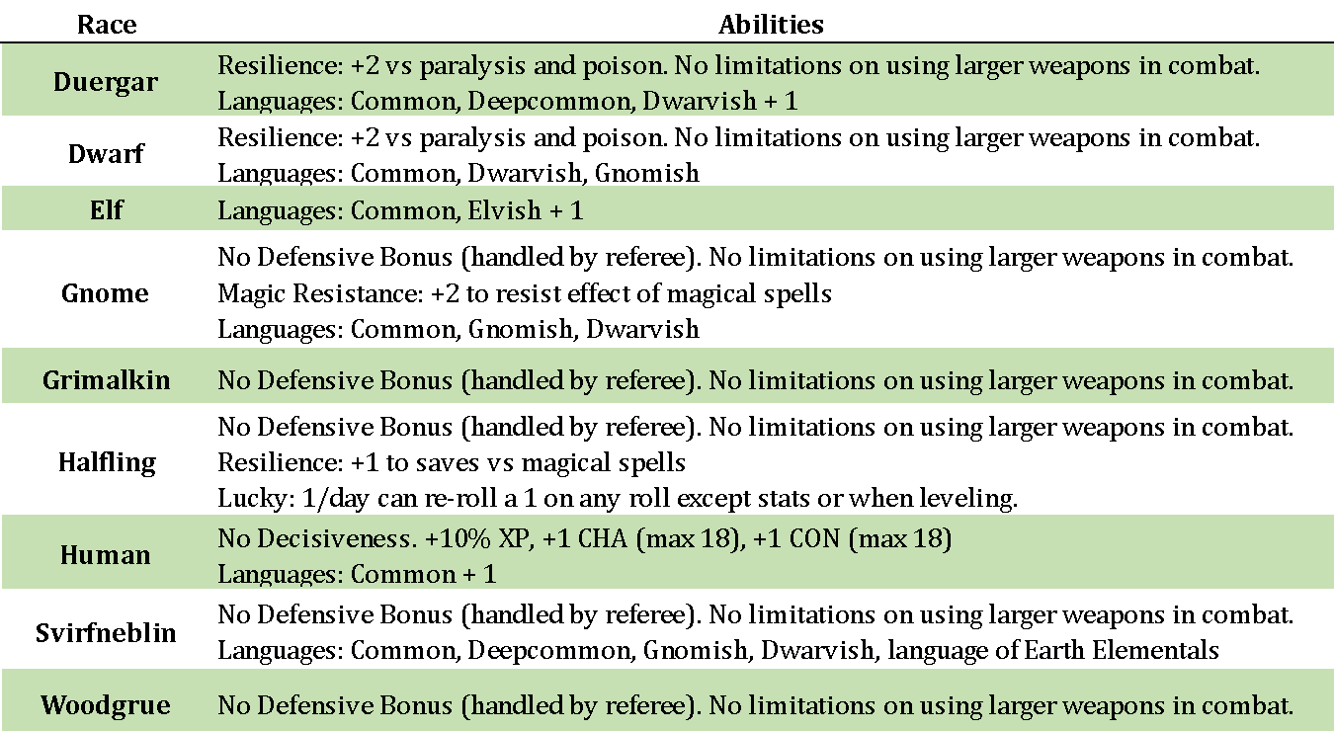If there is a conflict, the table rules below **supersede** book rules:

# General Class Information

* No XP bonus for stats (i.e., prime requisites).
* **Secondary Professions** will be used. Refer to the Secondary profession table (separate).

# Starting Equipment

* Starting gold is 3d6x10gp. Purchase what thou wilt. In the Dolmenwood setting, players will use the quick-start gear in the Dolmenwood Player’s Handbook.

# Movement - Per OSE Rules

* Types of Movement: **BASE, ENCOUNTER, EXPLORING**, and **TRAVELLING OVERLAND**.
* Movement is written as: **BASE (encounter)**.
* **Basic unencumbered movement is 120 (40)**.
* Movement is affected by **armor** and **Encumbrance**
* **ENCOUNTER** movement is **BASE/3** measured in **feet/round.**
* **EXPLORING** movement is **BASE** measured per **turn**
* **TRAVELLING** **OVERLAND** is **BASE/5** in **miles/day**
* Outdoors ranges and movement rates are measured in **yards** instead of **feet**. Spells remain in feet.

# Encumbrance

Encumbrance is measured using a **stone system.** One stone is equal to 14lbs. (1 STONE = 14lbs = 1 point of STR). This approach is intended to provide a simple and approximate means to track encumbrance. The rules are as follows:

* Carrying capacity is your character’s **STRENGTH** score in **STONES**
* **Bulky** items (e.g. large weapons, armor, tents, etc. ) are **rounded** **up** to the nearest **STONE**.
* **Small** items (e.g. rings, jewelry, vials, etc.) are **discounted entirely** *unless* stockpiled in *unusual* quantities.
* Other Items under a stone are grouped and roundedto the nearest **HALF-STONE (7lbs)**.
  + e.g. 20 arrows+quiver = ½ stone, 7 days of rations = ½ stone, lantern + 3 oil flasks = ½ stone
* Movement is reduced according to the table below
* Armor which is adorned is counted as half the encumbrance as armor which is stowed.
* **1000 COINS = 1 STONE**
* 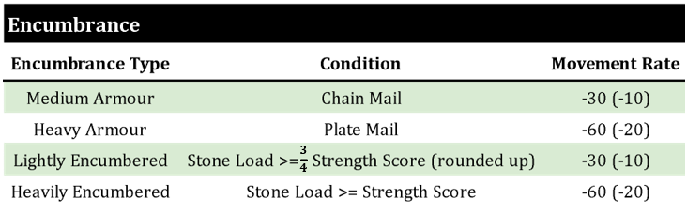Updated weapons, equipment and armor tables are included

# Weapon Proficiency, Specialization – PER OSE Optional Rules



# Attack Table

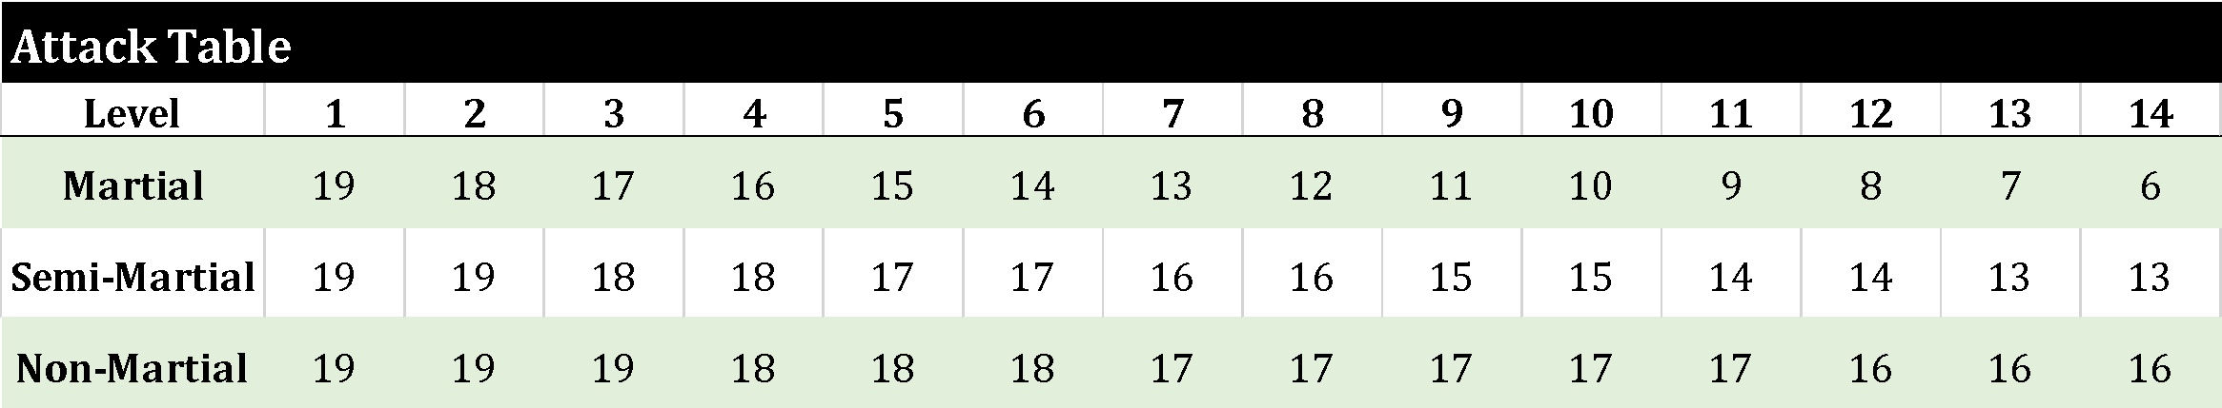**Spell Casting:** For any spell requiring a successful attack roll, the spell caster adds their prime requisite stat modifier (i.e. INT or WIS) and caster level to the roll.

Leveling & Hit Points

To gain a level requires training time and gold. Costs are based upon the requisite total XP for that level. Time must be spent in a safe location, appropriate for the character to advance at the standard rate. Accelerated training is performed under the tutelage of a master trainer, at a greater cost. If a character lacks the funds or facilities to properly study, training is performed at a decelerated rate. Training methods cannot be hybridized.

Level advancement requires the characters to devote time to reflect, study and hone the skills they have been developing while adventuring. This requires time spent in a safe refuge - a familiar town, barracks, church, library, or the like.

A character may begin training once they have earned at least three-quarters (75%) of the total XP needed for their next level, as measured from their current level’s XP threshold.

**---------------------------------------------------CLASSES--------------------------------------------------------**

## Acrobat (d6 Hit Die, Semi-Martial)

* Tightrope walking replaced by *Parkour!* because tightrope walking is gay.

## Assassin (d6 Hit Die, Semi-Martial)

* **Assassinate**: Assassins may attempt to instant-kill any unaware humanoid-like person using their Back-stab after studying their target for a minimum of 2 rounds to identify a most lethal attack prior to engagement. If the attack succeeds, the victim must make a saving throw or die instantly. If the assassinate fails but the attack succeeds, damage is dealt as a normal back-stab. An assassin may assassinate an opponent of hit die equivalent to the assassin’s class level plus 1d4HD, up to a maximum of 13HD.
* Can back-stab like a thief

## Bard (d6 Hit Die, Semi-Martial)

* Enchantment may be attempted a number of times per day equal to the bard’s level.

## Barbarian (d8 Hit Die, Martial)

* Fear of Magic - coordinated with the referee. Barbarians can wield limited magic weapons and certain items. “**Strike Invulnerable Monsters**” does not apply.

## Cleric (d6 Hit Die, Semi-Martial)

* Can create Holy Water. See: *Miscellaneous Notes Relevant to Classes*
* A cleric may keep indefinitely in their immediate possession a number of vials of holy water equal to 2+their level.
* When throwing Holy Water, a cleric’s attacks are rolled with advantage (roll twice, take best).
* Know 2 benedictions (level 0 spells), and gain an additional spell slot at levels 1, 2 and 3
* Clerics are **not limited** to blunt weapons

## Druid (d6 Hit Die, Non-Martial)

* Know 2 benedictions (level 0 spells), and gain 1 spell slot at levels 1, 2 and 3

## Fighter (d8 Hit Die, Martial)

* **Splinter Shield:** If a character would be dealt damage from an attack, they can opt to destroy their shield and fully mitigate the damage from the attack, provided their shield is donned and the attack is one that could be blocked.

## Friar /Beguine (d6 Hit Die, Non-Martial, ***Dolmenwood Only***)

* Can create Holy Water. See: *Miscellaneous Notes Relevant to Classes*
* A friar may keep indefinitely in their immediate possession a number of vials of holy water equal to 2+their level.
* When throwing Holy Water, a friar’s attacks are rolled with advantage (roll twice, take best).
* Know 2 benedictions (level 0 spells), and gain 1 spell slot at levels 1, 2 and 3
* A friar with access to proper herbal components may prepare 2 doses of a salve which accelerates natural recovery. Applying the salve allows a person to gain an additional 2hp during a restful night’s sleep. The salve requires 1 day to prepare and loses efficacy after 5 days.

Illusionist, Magic-User (Magician), Necromancer (d4 Hit Die, Non-Martial)

* Know 2 knacks (level 0 spells), and gain 1 spell slot at levels 1, 2 and 3
* May also use staves, slings
* Detect Magic is now a skill. See Miscellaneous Notes below and skill table above for specifics.

## Knights / **Dolmenwood** **Knights** (d8 Hit Die, Martial)

* **Splinter Shield:** If a character would be dealt damage from an attack, they can opt to destroy their shield and fully mitigate the damage from the attack, provided their shield is donned and the attack is one that could be blocked.
* Flying mounts can be accessed at 8th level

## Mages (d6 Hit Die, Non-Martial)

* Know 4 knacks (level 0 spells), and gain 1 spell slot at levels 1, 2 and 3.

## Paladin/Chaos Knight (d8 Hit Die, Martial)

* **Splinter Shield:** If a character would be dealt damage from an attack they can opt to destroy their shield and fully mitigate the damage from the attack, provided their shield is donned and the attack is one that could be blocked
* Paladins/CK’s access the spell table at +2 their level.
* A paladin may keep indefinitely in their immediate possession a number of vials of holy water equal to 1+their level.

## Ranger (d8 Hit Die, Martial)

* Rangers access the spell table as though they are 2 kevels higher (+2 their level).

## Thief (d6 Hit Die, Semi-Martial)

* Read Languages is now Decipher Docs. Allows for crude translation of basic instructions or notes. Complex languages or linguistic nuances cannot be deciphered. See skill table above.
* Thieves know “Thieves’ Cant”, the cryptolect of rogues and scoundrels

## 

**Note: Exceptional Stats grant a +1 to associated skill. No skill can exceed 11:12.**

# Miscellaneous Notes Relevant to Classes

* **Spell Casting:** For any spell requiring a successful attack roll, the spell caster adds their prime requisite stat modifier (i.e. INT or WIS) and caster level to the roll.
* Detect Magic, Detect Holy Magic is now a skill. Spell equivalents may still exist somewhere in the world…
* **Create Holy Water**: Requires an intense ritual lasting 1d4+3 days, using clean water and a ritual stoup worth 75gp (the stoup is reusable). The ritual produces enough holy water to fill 3 8-ounce vials (24oz total). Holy water must be stored in vials worth 5gp. Holy water is a vessel of divine power; as such, holy water no longer in the immediate possession of priest, cleric, paladin, friar, or sacristan loses its divine properties in 10 days or less depending upon circumstances. Augmenting the ritual with a Bless spell or using water from a Create Water spell increases the yield to 6 vials (48oz).
* **Detect Magic:** Requires touching item for 1 Turn. Failed attempts may be reattempted at higher levels.
* **Detect Holy Magic:** Requires touching item for 1 Turn. Failed attempts may be reattempted at higher levels.
* **Holy Water:** Deals **3d4 Damage** per round for 2 rounds**.** Holy water is a vessel of divine power. As such, holy water no longer in the immediate possession of a priest, cleric, paladin or sacristan loses its divine properties in 10 days or less depending upon circumstances.
* **Resurrection Spells:** Cannot be learned/acquired by normal means.
* **Turning/Command Undead:** Lowest Level undead are affected first. On a successful turning roll, the cleric may make another roll in the following round. This process may be repeated until all types of undead have been affected or a turning roll fails. One attempt per turn. Turning effect ends when monsters are out of line of sight of caster or caster ceases the turning prayer. Turning immediately ends on any monster which takes damage.
* There are **many more** **magic-user spells** that can be learned than what are listed in the OSE books.
* There are **many more cleric spells** that can be gifted than what are listed in the OSE books.

**---------------------------------------------------COMBAT--------------------------------------------------------**

# Initiative

Monsters vs Party: High roll on d6 goes first. For large combats, the referee will manage initiative using an app.

Crits and Fumbles  
Rolling a natural 20 or 1 will result in accessing the crit & fumble charts.

# Rest Healing

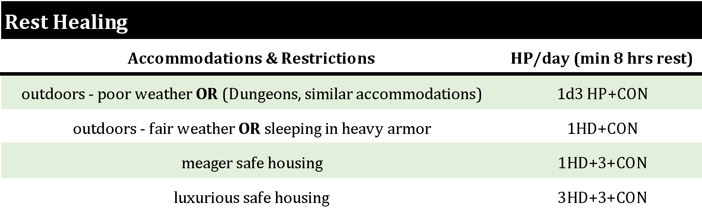Rest healing is granted based upon the hierarchical table below:

Combat Movement

Characters at range may make their full **ENCOUNTER** movement during the round. When engaged in melee, a character has 3 options regarding movement: **fighting retreat**, **full retreat**, and **disengage**.

* A **fighting retreat** allows characters to move half their **ENCOUNTER** movement and attack/defend.
* A **full retreat** allows a character to move their full **ENCOUNTER** movement but are subject to a free melee attack from adjacent engaged enemies.
* A **disengage** allows a character to move half their **ENCOUNTER** movement and will **not** incur a free melee attack from a number of adjacent engaged opponents equal to (20-THAC0)/2, rounded up. For example, a level 3 fighter with a THAC0 of 17 may successfully disengage from 2 adjacent creatures. A character who **disengages** may perform no other action that round.

# Combat

**Subdual Damage:** Attack rolls dealing subdual damage: roll twice, take worse result.

**Splash Damage:** 50% damage is dealt for 1 round iftarget AC is missed by 2 or less. 25% damage is dealt for 1 round if throwing at ground adjacent to target [AC 9].

**Longbow Damage**: Strength modifier is added to damage.

# Death & Dying

* 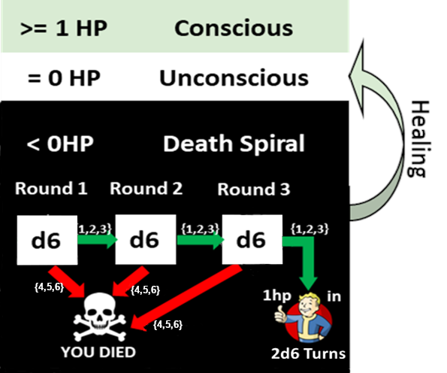A character at 0HP is **Unconscious**. Any healing received while **Unconscious** will render the character conscious.
* If the character falls below 0HP, they enter the **Death Spiral**. Any healing received while in the **Death Spiral** will render the character **Unconscious**.
* The **Death Spiral** lasts 3 rounds.
* Each round, roll a d6. Roll a 4, 5, or 6 and you die.
* If the player saves on 3 successive rounds, they stir with 1hp in 2d6 turns, or earlier if healing medicines or magics are applied.
* Sustaining damage while in the **Death Spiral** results in the decrement of the successful roll by 1, to a minimum of 1. For example, if a character in the **Death Spiral** is hit once, only a roll of 1 or a 2 will be considered a success; if damaged 2 or more times: only the roll of a 1 is a success.

**Fighting Monk (Semi-Martial)**

**Requirements:** WIS 12, DEX 12

**Hit Dice:** d6

**Maximum Level:** 14

**Armour:** none, no shield

**Weapons:** Missile weapons, dagger, short sword, spear, staff, polearm, fist weapons

**Languages:** Common

**Saves:** +3 bonus against paralysis and non-gaseous area of effect attacks

Fighting Monks are swift and skilled in close combat. Masters of mind and body, they can perform superhuman-like feats. Monks must treat treasure as do paladins. They may wear no armor.

**Ancient Medicines**

A fighting monk with access to proper herbal components may prepare 2 doses of a salve which accelerates natural recovery. Applying the salve allows a person to gain an additional 2hp during a restful night’s sleep. The salve requires 1 day to prepare and loses efficacy after 5 days.

**Armor Class**

When not wearing armor, the fighting monk gains a natural AC bonus (see **Fighting Monk Level Progression**). At 11th level the fighting monk is immune to mundane weapon damage from non-critical attacks while in combat.

**Awareness**

Fighting monks are only surprised on a roll of 1.

**Combat**

Fighting Monks master multiple unarmed fighting styles. When fighting unarmed, the monk must declare a fighting style during action declaration.  
At 3rd level, the fighting monk’s unarmed strikes are as effective as silvered weapons. At 5th level, the fighting monk’s unarmed strikes are as effective as magical weapons. 

**Deflect Missiles**

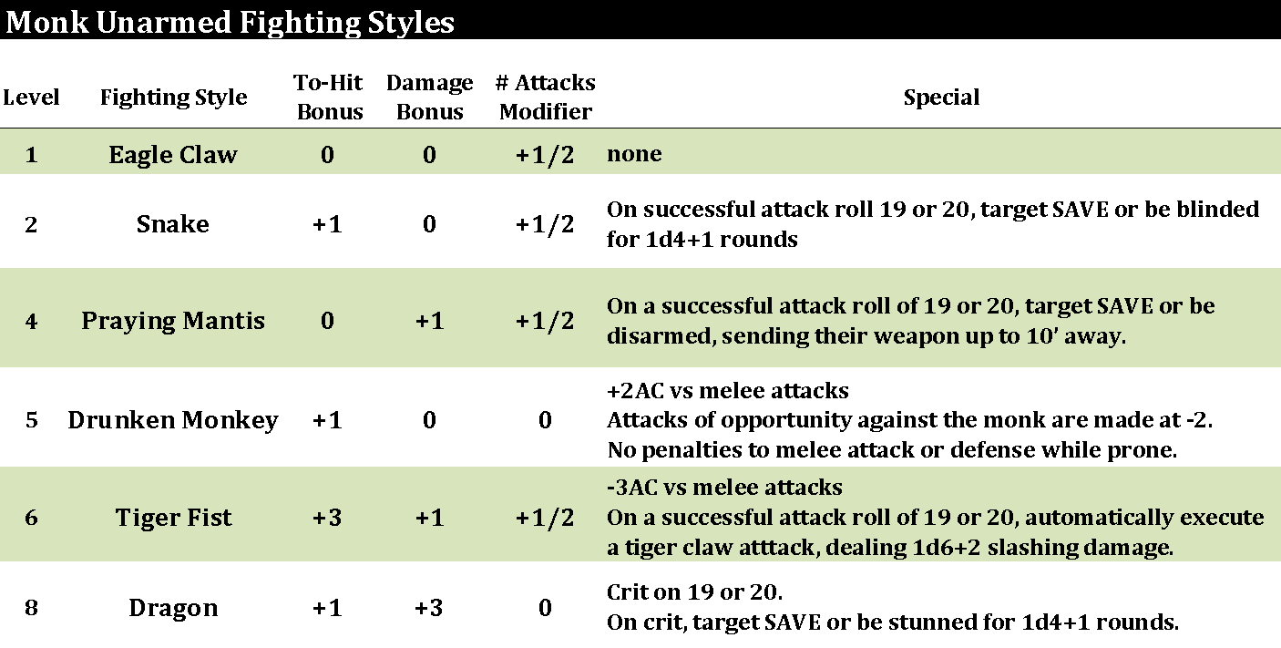Fighting Monks can deflect missile attacks with a successful saving throw.

**Iron Mind & Body**

A monk of 9th level or higher is immune to ESP, hold and slow spells, magical charms and Geas spells.  

**Fighting Monk Skills**

Fighting Monks possess the Climb Sheer Surfaces, Hear Noises and Move Silently skills as a Thief of the same level. Monks are able to use their keen wisdom to detect secret doors.

**Long Life**

At 10th level, monks age at 1/10th their normal rate. This has no impact on elves or any race that is innately gifted with Long Life.  

**Qi Powers**

Monks begin with a number of qi equivalent to one greater than their Wisdom modifier (minimum 1) and gain additional points as they level. Qi is fully restored with daily rest (see **Fighting Monk Level Progression**).

**Speak With Animals**

Fighting Monks can communicate intent, desire, and emotion with various animals. Fighting Monks select an animal language to learn at every level from the following: Eagle, Praying Mantis, Cockerel, Tiger, Crane, Leopard, Snake, Dragon (basic), Monkey, Bear, and Alligator.

**Speed**

BASE Movement speed increases 30 (10’ for ENCOUNTERS) every 3 levels. See **Movement** for more information.

**After Reaching 11th Level**

A fighting monk may establish or build a monastery, attracting (4d6x10) level 1-2 fighting monk students. These monks will train under the cruel tutelage of the fighting monk master.

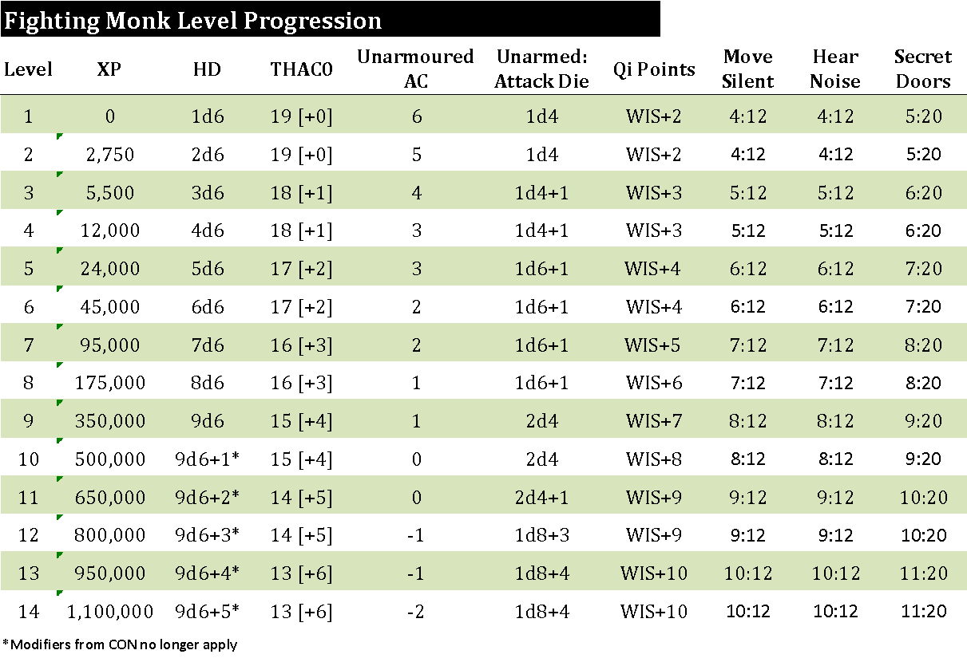 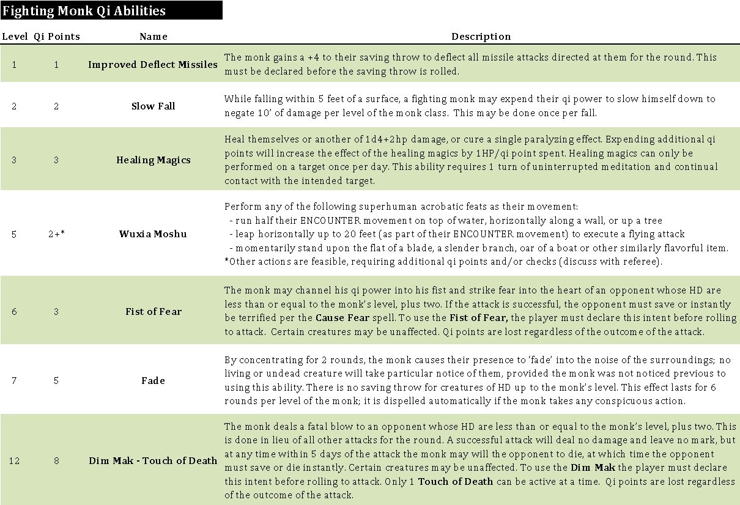

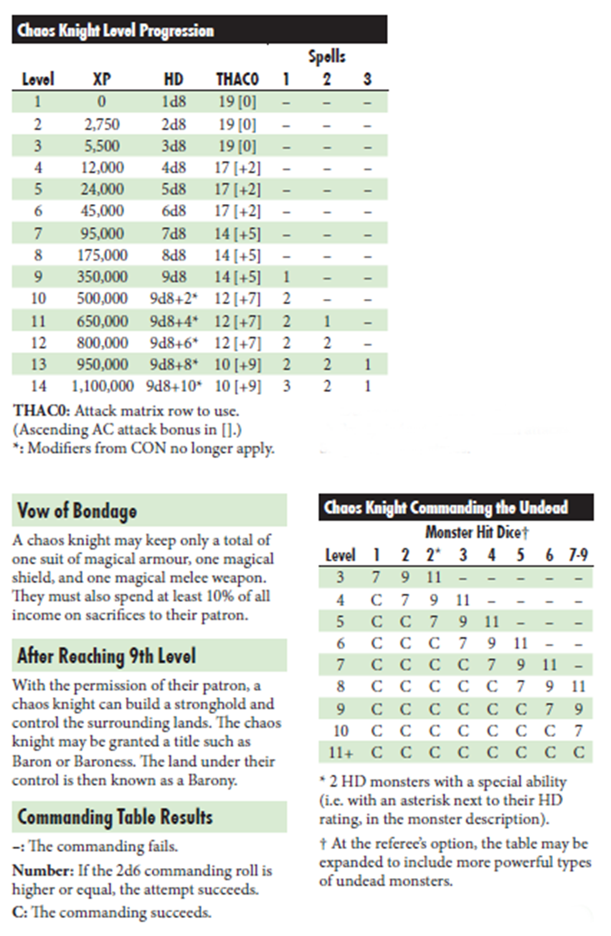

# 

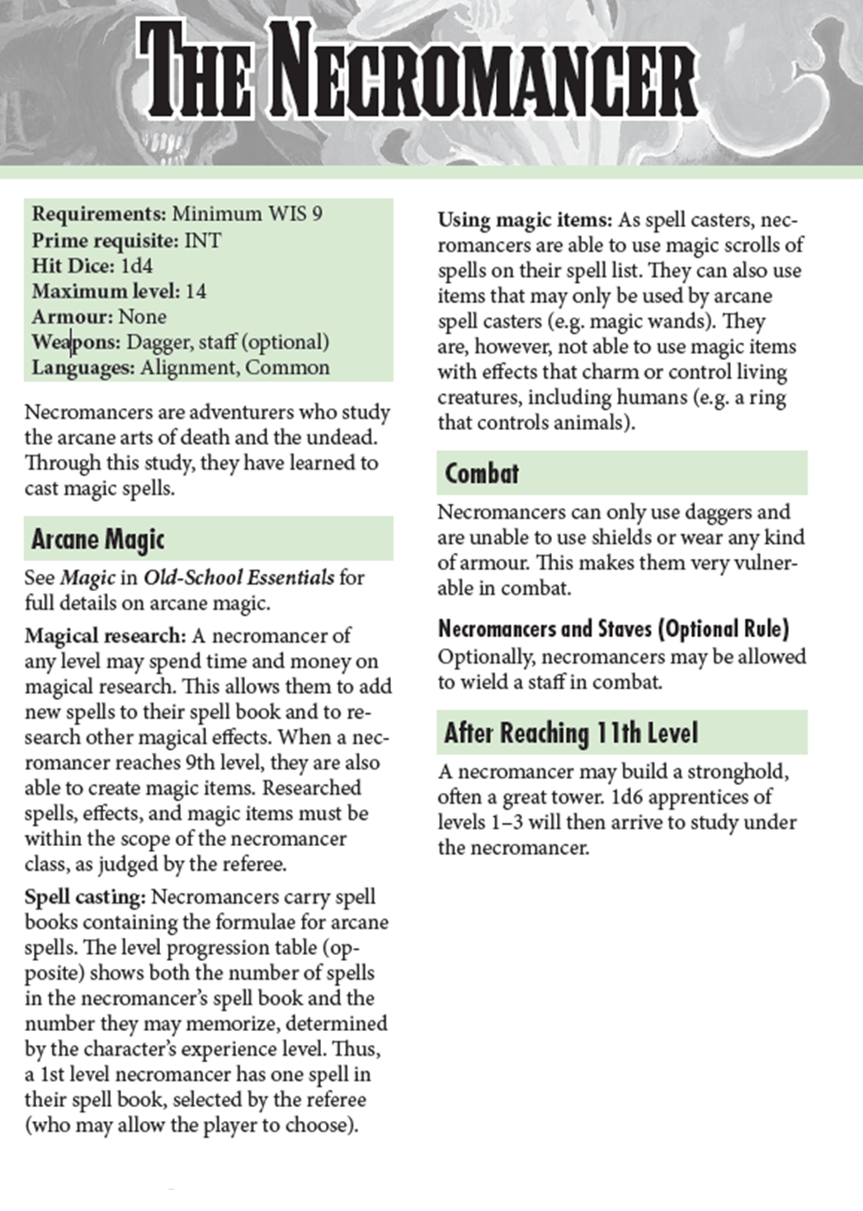

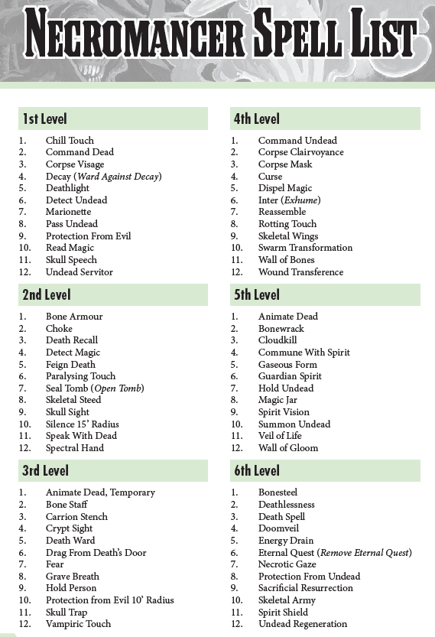

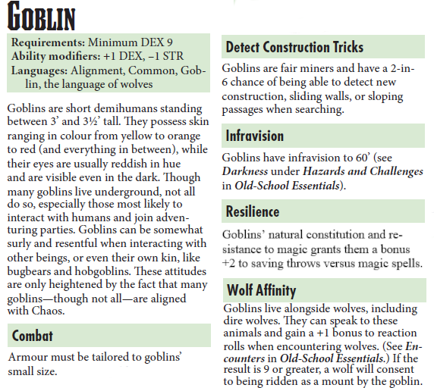

# **---------------------------------Knacks - Magic-User Level Zero Spells---------------------------------**

Note: Knacks are magical abilities inherent to the caster. These abilities are typically acquired by accident or coincidence. The accidental casting of a knack is not an uncommon way for a magic-user to recognize their own arcane talent. They require no time to memorize, cannot be taught, and are rarely forgotten. However, there is a limit to the number of times they can be cast before rest is required.

### Annoy/Embarrass Duration: 1 round Range: 30’

### A spell of this nature allows the caster to cause a slight annoyance upon the target it sees. The annoyance may take the form of a sneeze, cough, fart, belch, itch or similar mundane bodily annoyance. If the target fails its save, it is imparted with the temporary annoyance/embarrassment that may last no longer than 1 round.

### Chill Duration: 6 turns/level Range: 60’

A spell of this nature allows the caster to cause liquid or solid material up to 3 cubic feet (~22.4 gallons) to become cooler than it was, subject to a minimum temperature just above freezing (just below melting/boiling for reverse). The maximum temperature change achievable by these means is 40 degrees for non-living matter, 1 degree for living matter. The reverse of this spell warms by the same amount.

### Color Duration: 6 turns/level Range: 10’

This spell brings color to an object whose volume is no larger than 3 cubic feet. It can be used to restore faded hues or to tinge those already colored with a different hue. Thus, dull or faded fabric can be brightened, pigments restored, or even hair or skin changed to another color.

### Dampen/Dry

### Duration: permanent Range: 30’

This spell permeates a 10’x10’ area with a fog-like dampness which leaves all material within it damp to the touch. It is useful for many sorts of things. It is hard on parchment, and it similarly makes it and like substances hard to set aflame. The reverse, Dry, removes dampness and excess moisture from materials within the subject areas.

### Dust/Dusty

**Duration: permanent Range: 10’**

This spell removes a thin layer of fine dust and tiny grit particles (down to 25 microns in size!) from exposed surfaces such as floors, shelves, walls, etc. within a 100 square foot area. Material so removed is transported elsewhere, but new dust can accumulate, of course. Dusty, the reverse, causes a film of dust and grime to settle upon all exposed surfaces within the spell area of effect.

### Exterminate

**Duration: permanent Range: 30’**

When this spell is used, the caster may kill a small pest such as a fly, mouse, rat, beetle, or the like. It is useful for indoors and outdoors applications. If the subject is very small, an area of up to ½ cubic foot can be rid of pests. No saving throw under most circumstances.

### Firefinger/Extinguish

**Duration: 1 round Range: touch**

This spell enables the caster to cause a jet of flame up to 4 inches in length to shoot forth from his or her finger. The flame is very hot and will ignite combustible materials such as parchment, twigs, kindling, and the like without difficulty, providing the materials are relatively dry. If used on a living creature, it may deal up to 1 point of non-lethal damage (attack roll required). The reverse of this spell extinguishes a small flame such as used in a lantern or candle. A torch is too large a flame to be affected with this spell.

### Gather/Spill

**Duration: permanent Range: 30’**

This spell enables the caster to neatly gather numerous small objects within a 10’x10’ area into a stack or pile. For instance, if nails, nuts, coins, papers, or like objects were spilled, the magic would bring them together. It can be used selectively, for instance to separate one type of material from another, but only the selected type would be gathered neatly.  
Spill, the opposite of a gather spell, enables the caster to cause the contents of a container to spill out. The object container is actually tipped by the spell, and as it is not powerful, containers of more than about gallon size, or magical ones, will not be affected by the spell. Solids and/or liquids within the object container will spill out, providing the container is not securely closed or capped.

### Hairy/Shear

**Duration: permanent Range: 30’**

This spell causes hair, fur, or hair-like growth to thicken and lengthen. Thus, a head of hair, a peach, a beard, a cat, or whatever could be affected. The growth will cause the subject material to increase from 2-12 inches in length. The subject material must be trimmed or cut to remove the spell’s effect. This spell can be reversed to shorten growth or effectively shave, but as the effect on short material (growth under 1 inch in length) is complete absence of growth for 2-12 days, it is not often used.

### Inscribe

### Duration: permanent Range: 30’

### This cantrip engraves up to 1 square foot of writing or drawing onto most common surfaces.

### Spice

**Duration: permanent Range: touch**

This magic actually brings a particular spice to the object food or drink. Thus, ginger, pepper, and like spices can be brought to add zest (or disguise). Herbs like bay leaf, garlic, parsley, etc. can likewise be evoked by this. The quantity is sufficient to spice food or drink for about a dozen people. The spice (or herb) appears over the object vessel as a fine powder or flake, falls upon it, and adds its substance to the dish or drink. The spell can affect up to 1 cubic foot of material.

### Sweeten/Sour

**Duration: permanent Range: touch**

This spell is the same as a spice spell, except that the result is the evocation of a sweetener — sugar, honey, or even a syrup.  When the reverse spell is employed, the caster causes the subject food or drink to take on a sour taste, not unlike vinegar of the appropriate sort.  The spell can affect up to 1 cubic foot of material.

### Tie/Untie

**Duration: permanent Range: 20’**

By means of this spell the caster can magically cause the object — thread, string, cord or rope— to create a simple half-knot to either its other end or an end of a similar object within 1’ of it. The reverse of the spell removes a simple knot or tying. Note that the untie spell will cause a tangle to be nullified. The spell will not remove both a knot and a normal tying (normal knot or one caused by a tie spell), but it will cause the former to disappear so that only a normal tying remains.

### Wrap/Unwrap

**Duration: permanent Range: 20’**

When a wrap spell is employed, the caster creates a strong and sturdy wrapping around the subject desired — a bit of herbs, a heap of flour, a bundle of cloth, etc. The material produced by the spell is of the spell is of a suitable type and thickness for the item(s) to be wrapped. Thus, a few ounces of fine powder will be contained in a waxy tissue, gem stones in a felt-like envelope, meal in cloth, and so forth. The spell will wrap up to 1 cubic foot of material. The reverse of this spell will cause a suitably wrapped item to unwrap itself.

# **-------------------------------Benedictions - Cleric Level Zero Spells----------------------------------**

Note: Benedictions are magical gifts given to a cleric or priest by their deity. These abilities are typically acquired by accident or coincidence. These are often the first signs of divine channeling in a cleric’s life. Benedictions require no time to memorize, cannot be taught, and are rarely forgotten. However, there is a limit to the number of times they can be cast before rest is required.

### Alleviate/Inflict

**Duration: 6 turns/level Range: 10’**

This spell temporarily alleviates a common cold or flu symptom a person may be experiencing, such as a sniffling, sneezing coughing, aching, stuffy head, fever, runny nose, etc. Onset of the alleviation of these symptoms occurs within 1d6 minutes. The reverse, Inflict, will instill such a symptom on a person (save vs spell required).

### Glow

**Duration: 1 turn Range: 30’**

This spell causes an object no larger than 1 cubic foot to begin to glow with the holy aura of the cleric’s deity. The glow is slightly noticeable in bright daylight, and will dimly illuminate a 10’ area.

### Clean/Dirty

**Duration: permanent Range: 30’**

This spell removes heavy soil, dirt, and like foreign objects from floors, walls, dishes, windows, etc. in an ear up to 10 square feet. The subject surfaces are then spotless, but care must be taken in removal of pigments and the like, so usually only one type of material will be treated in a single application.   
The reverse of this spell, Dirty, lets casters soil, spot, and sully walls, floors, dishes, garments, etc.

### Consecrate Meal

**Duration: permanent Range: 5’**

By means of this spell the caster says a prayer before a meal to sanctify it in the name of his deity. Consuming this meal within the next two turns may impart benefits to characters of similar alignments and beliefs as the cleric and his deity. The benefits of this spell can only be gained once a day. Benefits are determined on a d6 as follows: [1-2] Characters feel invigorated and may travel an additional 2 hours on foot that day before feeling exhaustion, [3-4] Characters feel sated and require half their normal intake of food and water for the day, [5] Effects of [1-2,3-4] plus +1 on all morale/charisma checks for the next 4 hours, [6] Effects of [1-2,3-4,5] plus 1hp of health is restored.

### Flavor

**Duration: 1 turn/level Range: 10’**

This spell enables the caster to give the subject a superior or better or different flavor. Thus, much can be made to taste as if it were lobster bisque, but the dweomer will not actually affect the quality or wholesomeness of the subject. Spoiled food remains spoiled; a poisoned drink would still be deadly.

### Sprout Duration: permanent Range: 30’

By means of this spell the caster causes the slight acceleration in the growth of plants, particularly with respect to the germination of plant seeds. Upon casting, the spell will cause seeds to shoot forth tiny sprouts, buds to flower, etc. Fruits and vegetables can be caused to slightly ripen (or actually go past ripening to spoilage) by this spell.

### Freshen/Taint

**Duration: permanent Range: touch**

By means of this spell the caster brings new life or freshness to the object desired. The magic applies to food and drink items such as milk, beer, meat, and raw vegetables. It also works with cut vegetables, flowers, herbs, etc. It will remove slight taint/spoilage of an item up to 1 cubic foot (7.5 gallons) in size. The reverse of the Freshen spell can cause a plant to wilt (or possibly wither if it is not very healthy) or a bunch of cut flowers sag and droop. It can cause milk to curdle slightly hastens spoilage or wilting.

### Salt

**Duration: 6 turns/level Range: 5’**

This spell causes 1 pound of fine salt to magically appear and descend upon the desired object — a stew, some troublesome weed patch, or a barrel full of stock fish to be preserved, etc. Any salt which is not consumed/dissolved/used at the end of the duration magically vanishes.

### Shine/Tarnish

### Duration: 6 turns/level Range: touch

This spell allows the caster to remove tarnish, rust, corrosion, and like substances from the desired object. This spell brings about a mirror-bright shine to objects capable of such, causing their surfaces to be smooth and unmarred. A piece of jewelry, for instance, would be made more attractive. A single object up to about 1 cubic yard in volume can be treated by this spell.  
Tarnish, the reverse of a shine spell, causes a covering of rust, corrosion, verdigris, or the like to cover an object normally subject to such tarnishing. The object must be of about 1 cubic yard or less in volume.

### Water to Wine

### Duration: permanent Range: 10’

This spell will permanently turn up to 1 gallon of water into wine common to the area. The reverse of this spell will convert up to 1 gallon wine to water.

# **--------------------------------------SECONDARY PROFESSION LIST-----------------------------------------**

Roll d100 to find the table to index, then roll a second d100 to determine your secondary profession.

|  |  |
| --- | --- |
| 1-8 | **Agriculture, Animals & Forestry** |
| 9-16 | **Architecture & Construction** |
| 17-23 | **The Arts** |
| 24-30 | **Business & Trade** |
| 31-37 | **Communications** |
| 38-44 | **Craftsmanship** |
| 45-51 | **Crime** |
| 52-58 | **Government & Law** |
| 59-65 | **Hospitality and Common Labor** |
| 66-72 | **Military & Security** |
| 73-79 | **Religion** |
| 80-86 | **Sciences & Education** |
| 87-93 | **Transportation** |
| 94-100 | **Self(or Un)-Employed or Outcast** |

**Agriculture, Animals & Forestry**

|  |  |
| --- | --- |
| 1-3 | Animal/Monster Handler – responsible for the safe keeping, dietary care, and exercise of animals or monsters. |
| 4-6 | Arborist – maintains and cares for trees, often by surgically removing dying limbs. |
| 7-9 | Baler – bales hay, or in the mills, wool and cotton goods. |
| 10-11 | Beekeeper – owns and breeds bees, especially for their honey. |
| 12-14 | Breeder – breeds livestock, animals, or monsters. |
| 15-17 | Cowherd – supervises grazing cattle. |
| 18-20 | Dairyboy/Dairymaid – milks cows and makes cheese and butter. |
| 21-23 | Falconer – keeps, trains, and hunts with falcons, hawks, or other birds of prey. |
| 24-26 | Farmer – operates a farm or cultivates land. |
| 27-29 | Fisher – catches fish. |
| 30-31 | Florist – grows and arranges plants and cut flowers. |
| 32-34 | Forager – searches for food in the wild. |
| 35-37 | Forester – supervises the wellbeing of a forest. |
| 38-40 | Fowler – catches or ensnares birds. |
| 41-43 | Gamekeeper – breeds and protects game, typically for a large estate. |
| 44-46 | Groom – cleans and brushes the coats horses, dogs, or other animals. |
| 47-49 | Herder – supervises a herd of livestock or makes a living from keeping livestock, especially in open country. |
| 50-51 | Horse Trainer – tends to horses and teaches them different disciplines. |
| 52-54 | Hunter – hunts game or other wild animals. |
| 55-57 | Lumberjack – fells trees, cuts them into logs, and transports them to a sawmill. |
| 58-60 | Master-of-Horses – supervises and commands all horses under a jurisdiction. |
| 61-63 | Master-of-Hounds – maintains a pack of hounds and their associated staff, equipment, and hunting arrangements. |
| 64-66 | Miller – owns or works in a grain mill. |
| 67-69 | Miner – works underground in mines in order to obtain minerals such as coal, diamonds, or gold. |
| 70-71 | Pathfinder – scouts ahead and discovers a path or way for others. |
| 72-74 | Plumer – hunts birds for their plumes. |
| 75-77 | Prospector – searches for mineral deposits, especially by drilling and excavation. |
| 78-80 | Ranger – wanders or ranges over a particular area or domain. |
| 81-83 | Renderer – converts waste animal tissue into usable materials. |
| 84-86 | Shepherd – herds, tends, and guards sheep. |
| 87-89 | Stablehand – works in a stable. |
| 90-91 | Thresher – separates grain from the plants by beating. |
| 92-94 | Trapper – traps wild animals, especially for their fur. |
| 95-97 | Vintner – engages in winemaking, especially with monitoring and harvesting the grapes. |
| 98-100 | Zookeeper – maintains and cares for animals or monsters in a zoo. |

**Architecture & Construction**

|  |  |
| --- | --- |
| 1-9 | Architect – designs buildings or landscapes and in many cases supervises their construction. |
| 10-18 | Brickmaker – crafts bricks from clay, stone, or other materials. |
| 19-27 | Brickmason – builds with mineral products such as stones, bricks, tiles, etc. usually with the use of mortar. |
| 28-36 | Carpenter – makes and repairs wooden objects and structures. |
| 37-45 | Construction Worker – a laborer in the physical construction of a built environment and its infrastructure. |
| 46-55 | General Contractor – supervises a construction site, manages its vendors and trades, and associated communication. |
| 56-64 | Glazier – fits glass into windows and doors. |
| 65-73 | Plasterer – applies plaster to walls, ceilings, or other surfaces. |
| 74-82 | Roadlayer/Streetlayer – paves roads or streets. |
| 83-91 | Roofer/Thatcher – builds and repairs roofs. |
| 92-100 | Stonemason – cuts and prepares stone for use in construction. |

**The Arts**

|  |  |
| --- | --- |
| 1-2 | Acrobat – performs spectacular gymnastic feats. |
| 3-5 | Actor – impersonates characters, typically on stage in a theatrical production. |
| 6-7 | Aerialist/Trapezist – performs acrobatics high above the ground on a tightrope or trapeze. |
| 8-10 | Arranger – adapts a musical composition for performance. |
| 11-12 | Athlete – proficient in sports and other forms of physical exercise. |
| 13-15 | Busker/Street Musician – performs in a public place, often for money. |
| 16-17 | Celebrity – a famous person. |
| 18-20 | Chef – a professional cook trained in the culinary arts. |
| 21-22 | Choirmaster – trains a choir and orchestrates their singing when they perform. |
| 23-24 | Clown – comic entertainer who wears a traditional costume and exaggerated makeup. |
| 25-27 | Comedian – entertainer whose act is designed to make an audience laugh. |
| 28-29 | Conductor – directs the performance of an orchestra. |
| 30-32 | Contortionist – twists and bends their body into strange and unnatural positions. |
| 33-34 | Curator – keeper and custodian of a museum or other collections of precious items. |
| 35-37 | Costumer – makes theatrical costumes. |
| 38-39 | Dancer – moves their body rhythmically with or without musical accompaniment. |
| 40-41 | Equilibrist – performs balancing feats. |
| 42-44 | Fashion Designer – applies design, aesthetics and natural beauty to garments and their accessories. |
| 45-46 | Gladiator – fights against other people, wild animals, or monsters in an arena. |
| 47-49 | Glasspainter – produces colorful designs on or in glass. |
| 50-51 | Jester – professional joker or “fool” at court, typically wearing a cap with bells on it and carrying a mock scepter. |
| 52-54 | Juggler – keeps several objects in motion in the air at the same time by alternately tossing and catching them. |
| 55-56 | Illuminator – paints and calligraphs to adorn or enlighten scrolls and manuscripts. |
| 57-59 | Limner – paints portraits or miniatures. |
| 60-61 | Makeup Artist – applies cosmetics to models, actors, nobles, etc. |
| 62-63 | Minstrel – recites lyric or heroic poetry for nobility. |
| 64-66 | Model – poses as a subject for an artist, fashion designer, or sculptor. |
| 67-68 | Musician – plays a musical instrument. |
| 69-71 | Painter – paints pictures. |
| 72-73 | Playwright – writes plays or musicals. |
| 74-76 | Poet – writes ballads, epics, sonnets, or other forms of poetry. |
| 77-78 | Ringmaster/Ringmistress – master of ceremony who introduces the circus acts to the audience. |
| 79-80 | Ropewalker – walks along a tightrope to entertain others. |
| 81-83 | Sculptor – crafts art by carving or casting blocks of marble, stones, or other hardened minerals. |
| 84-85 | Singer/Soprano – sings with or without instrumental accompaniment. |
| 86-88 | Stage Magician – deceives their audience with seemingly impossible feats while using only natural means. |
| 89-90 | Stuntman/Stuntwoman – performs dangerous stunts for their audience. |
| 91-93 | Tattooist – illustrates the skin with indelible patterns, pictures, legends, etc. |
| 94-95 | Theater Director –orchestrates the mounting of a theatre production. |
| 96-98 | Wrestler – performs in matches involving grappling and grappling-type techniques. |
| 99-100 | Writer – commits his or her thoughts, ideas, etc., into written language. |

**Business & Trade**

|  |  |
| --- | --- |
| 1-4 | Accountant – keeps and inspects financial accounts. |
| 5-7 | Actuary – compiles and analyzes statistics and uses them to calculate risk. |
| 8-11 | Animal Collector/Monster Collector – collects and deals in rare and exotic animals and monsters. |
| 12-14 | Business Owner – owns a business entity in an attempt to profit from its successful operations. |
| 15-18 | Debt Collector – recovers money owed on delinquent accounts. |
| 19-21 | Draper – an alcohol merchant. |
| 22-25 | Appraiser – assesses the monetary value of something. |
| 26-29 | Auctioneer – conducts auctions by accepting bids and declaring goods sold. |
| 30-32 | Banker – an officer or owner of a bank or group of banks. |
| 33-36 | Bagniokeeper – owner of a bath house or brothel. |
| 37-39 | Bookkeeper – keeps records of financial affairs. |
| 40-43 | Chandler – deals in provisions and supplies. |
| 44-46 | Collector – collects things of a specified type, professionally or as a hobby. |
| 47-50 | Entrepreneur –operates a business or businesses, taking on greater than normal financial risks in order to do so. |
| 51-54 | Grocer – a food merchant. |
| 55-57 | Guild Master – leads an economically independent producer (a “guild,” an association of craftsmen or merchants). |
| 58-61 | Innkeeper – owns and runs an inn. |
| 62-64 | Land Surveyor – establishes maps and boundaries for ownership or other purposes as required. |
| 65-68 | Merchant – sells and trades goods. |
| 69-71 | Moneychanger – exchanges one currency for another. |
| 72-75 | Moneylender – lends money to others who pay interest. |
| 76-79 | Peddler – travels from place to place selling assorted items. |
| 80-82 | Pimp/Madame – controls prostitutes and arranges clients for them, taking part of their earnings in return. |
| 83-86 | Plantation Owner – an owner of an estate on which crops are cultivated by resident labor, typically slave labor. |
| 87-89 | Speculator – invests in stocks, property, or other ventures in the hope of making a profit. |
| 90-93 | Thriftdealer – deals in secondhand items. |
| 94-96 | Tradesman – deals exclusively in bartering. |
| 97-100 | Vendor – deals items in the street. |

**Communications**

|  |  |
| --- | --- |
| 1-13 | Billboardposter – a person who puts up notices, signs and advertisements. |
| 14-25 | Courier – transports packages and documents. |
| 26-38 | Herald – a messenger who carries important news. |
| 39-50 | Interpreter – interprets language and its meaning, especially within ancient manuscripts. |
| 51-63 | Linguist – studies the essence of communication, including the units, nature, structure, and modification of language. |
| 64-75 | Messenger – carries messages between recipients. |
| 76-88 | Town Crier – makes public announcements in the streets or marketplace. |
| 89-100 | Translator – translates between languages. |

**Craftsmanship**

|  |  |
| --- | --- |
| 1-2 | Accoutrementer/Coinsmith – makes currency for the government. |
| 3-4 | Armorer – specializes in making and repairing armor. |
| 5-6 | Blacksmith – forges and repairs things in metal, including weapons, armor, utensils, etc. |
| 7-8 | Bladesmith – specializes in making and repairing bladed weapons, especially swords and daggers. |
| 9-10 | Bookbinder – binds books and wraps scrolls. |
| 11-12 | Bottler – bottles drinks and other liquids. |
| 13-14 | Bowyer – makes bows and crossbows. |
| 15-16 | Brewer – brews ale. |
| 17-18 | Broom Maker – makes brooms and brushes. |
| 19-20 | Candlemaker – makes candles and wax from honey and tallow. |
| 21-22 | Cartwright – makes and repairs carts and wagons. |
| 23-24 | Cobbler – makes and repairs footwear. |
| 25-26 | Cooper/Hooper – makes and repairs casks and barrels. |
| 27-28 | Cutler – makes cutlery. |
| 29-30 | Dyer – dyes cloth and other materials. |
| 31-32 | Embroiderer – ornaments with needlework. |
| 33-34 | Engraver – incises a design onto a hard surface by cutting grooves into it. |
| 35-36 | Farrier – trims and shoes horses' hooves. |
| 37-38 | Fletcher – makes and repairs arrows. |
| 39-40 | Furniture Artisan – makes and repairs furniture. |
| 41-42 | Furrier – prepares furs for adornment. |
| 43-44 | Glassworker – blows glass planes and items. |
| 45-46 | Glovemaker – makes and repairs gloves. |
| 47-48 | Goldsmith/Silversmith – a smith who specializes in precious metals. |
| 49-50 | Hatter/Milliner – makes and repairs headwear. |
| 51-52 | Instrument Maker – makes and repairs musical instruments. |
| 53-54 | Lapidary – turns stone/minerals/gemstones into decorative items such as cabochons, engraved gems, etc. |
| 55-56 | Leatherworker – makes items from leather such as pouches, scabbards, straps, etc. |
| 57-58 | Jeweler – designs, makes, and repairs necklaces, bracelets, watches, etc., often containing jewels. |
| 59-60 | Locksmith – makes and repairs locks. |
| 61-62 | Luthier – makes and repairs stringed instruments. |
| 63-64 | Mercer – weaves textile fabrics, especially silks, velvets, and other fine materials. |
| 65-66 | Optician – makes and repairs eyeglasses. |
| 67-68 | Potter – makes pots, bowls, plates, etc., out of clay. |
| 69-70 | Printer – a person who applies pressure to an inked surface resting upon a print medium (such as paper or cloth). |
| 71-72 | Restorer – repairs or renovates a work of art so as to return it to its original condition. |
| 73-74 | Ropemaker – braids rope. |
| 75-76 | Rugmaker – makes and repairs rugs by braiding, hooking, weaving, etc. |
| 77-78 | Saddler – makes and repairs saddlery. |
| 79-80 | Seamstress/Tailor – makes, alters, repairs, as well as occasionally designing garments. |
| 81-82 | Soaper – makes soap from accumulated mutton fat, wood ash, and natural soda. |
| 83-84 | Tanner – treats the skins and hides of animals to produce leather. |
| 85-86 | Taxidermist – prepares, stuffs, and mounts the skins of animals. |
| 87-88 | Tinker – travels from place to place mending utensils. |
| 89-90 | Toymaker – makes and repairs toys. |
| 91-92 | Watchmaker – makes and repairs watches and clocks. |
| 93-94 | Weaponsmith – specializes in making and repairing weapons. |
| 95-96 | Weaver – makes fabric by weaving fiber together. |
| 97-98 | Wheelwright – makes and repairs wooden wheels. |
| 99-100 | Whittler/Woodcarver – fashions wood into various shapes. |

**Crime**

|  |  |
| --- | --- |
| 1-6 | Assassin – murders through stealth for reasons pertaining to money, politics, or religion. |
| 7-12 | Bandit – a robber or outlaw belonging to a gang and typically operating in an isolated or lawless area. |
| 13-18 | Burglar – illegally enters buildings and steals things. |
| 19-24 | Charlatan/Conman-  person who exploits the  others for their own sake by manipulation of their confidence |
| 25-29 | Cockfighter/Gamefighter – engages in matches in which creatures are pitted against one another, typically to death. |
| 30-35 | Drug Dealer – dealer of illegal substances. |
| 36-41 | Extortioner – extorts money from someone by threatening to expose embarrassing information about them. |
| 42-47 | Fence – deals in stolen goods. |
| 48-53 | Forger – produces fraudulent copies or imitations. |
| 54-59 | Fugitive – a person who has escaped from a place or is in hiding, especially to avoid arrest or persecution. |
| 60-65 | Highwayman – robs travelers on a road. |
| 66-71 | Kidnapper – abducts people and holds them captive, typically to obtain a ransom. |
| 72-76 | Loan Shark – charges extremely high rates of interest for moneylending, typically under illegal conditions. |
| 77-82 | Pirate – attacks and robs ships at sea. |
| 83-88 | Poacher – hunts illegal game. |
| 89-94 | Raider/Marauder – makes sudden, unprompted attacks against defenseless or near-defenseless settlements. |
| 95-100 | Smuggler –imports/exports goods secretly, in violation of the law, especially without payment of legal duty. |

**Government & Law**

|  |  |
| --- | --- |
| 1-5 | Affeeror – determines the values of fines and amercements. |
| 6-10 | Agister – affords pasture to the livestock of others for a price. |
| 11-15 | Alderman – a civic dignitary in the local council ranked below the mayor. |
| 16-20 | Alienist – assesses the competence of a defendant in a court of law. |
| 21-25 | Assay Master – oversees the testing of currency. |
| 26-30 | Chief – leads or rules a people or clan. |
| 31-35 | Conservationist – advocates for the protection and preservation of the environment and wildlife. |
| 36-40 | Judge – decides cases in a court of law. |
| 41-45 | Lady-in-Waiting – attends a queen, princess, or other high-ranking feminine nobleperson. |
| 46-50 | Lawyer/Advocate – practices or studies law, typically an attorney or a counselor. |
| 51-55 | Minister – assists with the administration of business. |
| 56-60 | Noble/Aristocrat – a person belonging to a class with high social or political status. |
| 61-65 | Notary – performs certain legal formalities, draw up or certify contracts, deeds, and other documents for use. |
| 66-70 | Orator/Spokesman – makes statements on behalf of a group or individual nobleperson. |
| 71-75 | Page – a young attendant to a person of noble rank. |
| 76-80 | Sheriff – the chief executive officer in a county, having various administrative and judicial functions. |
| 81-85 | Steward – supervises both the estate and household of his lord or lady while they are away. |
| 86-90 | Squire – acts as an attendant to a knight before attempting to become a knight themselves. |
| 91-95 | Tax Collector – collects unpaid taxes from people, guilds, or businesses. |
| 96-100 | Ward – a member of a noble house who has been taken in by another noble family to be raised for a time. |

**Hospitality and Common Labor**

|  |  |
| --- | --- |
| 1-2 | Acater – provides and prepares foodstuffs or delicacies for events such as festivals. |
| 3-5 | Tunner – fills casks in a brewery or winery. |
| 6-7 | Baker – bakes bread and cakes. |
| 8-9 | Barber – cuts hair and shaves or trims beards. |
| 10-12 | Barkeep – works and serves drinks in a bar. |
| 13-14 | Barmaid/Barboy – serves drinks and food in a bar as well as engaging with customers. |
| 15-16 | Butcher – cuts up and sells meat. |
| 17-19 | Butler – the chief servant of a household. |
| 20-21 | Caregiver – looks after a sick, elderly, or disabled person. |
| 22-23 | Charcoal Maker – manufactures charcoal by carbonizing wood in a kiln. |
| 24-26 | Chatelaine/Majordomo – a person in charge of a large household. |
| 27-28 | Chimney Sweeper – a small person, typically a child, who ascends chimneys to clean them. |
| 29-30 | Clerk – undertakes routine administrative duties in a business or bank. |
| 31-33 | Cook – prepares food for eating. |
| 34-35 | Copyist – makes copies of handwritten documents or music. |
| 36-37 | Croupier – runs a gaming table by gathering in and paying out money or tokens. |
| 38-40 | Exterminator – exterminates unwanted rodents and insects. |
| 41-42 | Food & Drink Taster – ingests food that was prepared for someone else to confirm it is safe to eat. |
| 43-44 | Gardener/Landscaper – tends and cultivates a garden. |
| 45-47 | Gongfarmer – digs out and removes excrement from privies and cesspits. |
| 48-49 | Gravedigger – digs graves for the purposes of a funeral ceremony. |
| 50-51 | Groundskeeper – maintains an athletic field, a park, or the grounds of a graveyard or other institution. |
| 52-53 | Kitchen Drudge – performs menial work in a kitchen. |
| 54-56 | Knacker – disposes of dead or unwanted animals. |
| 57-58 | Lamplighter – lights street or road lights at dusk. |
| 59-60 | Laundry Worker – a laborer who takes part in the washing, drying, and ironing of clothes and other fabric items. |
| 61-63 | Lector – reads to others while they work for entertainment. |
| 64-65 | Longshoreman – loads and unloads ships in a port. |
| 66-67 | Maid – a domestic servant of a household. |
| 68-70 | Nanny/Nursemaid – a servant employed to look after a young child or children. |
| 71-72 | Operator – a laborer who operates equipment, typically in construction. |
| 73-74 | Pastry Chef – makes desserts, especially cakes and pastries. |
| 75-77 | Plumber – installs and repairs the fittings of water supply and sanitation. |
| 78-79 | Porter – carries luggage and other loads. |
| 80-81 | Prostitute – engages in sexual activity for payment. |
| 82-84 | Quarryman/Quarrywoman – quarries stone. |
| 85-86 | Servant – performs duties for others, especially a person employed in a house or as a personal attendant. |
| 87-88 | Stagehand – moves scenery or props before or during the performance of a theatrical production. |
| 89-91 | Street Cleaner – cleans streets and alleyways after dark. |
| 92-93 | Talent Scout – searches for talented individuals who can be employed or promoted. |
| 94-95 | Trainer – trains someone in a particular skill, usually physical, for money. |
| 96-98 | Water Bearer – brings water from rivers, wells, and lakes back to their settlement. |
| 99-100 | Wet Nurse – a woman employed to suckle another woman's child. |

**Military & Security**

|  |  |
| --- | --- |
| 1-3 | Bailiff – looks after prisoners. |
| 4-6 | Bodyguard – escorts and protects another person, especially a dignitary. |
| 7-9 | Bouncer – prevents troublemakers from entering or to eject them from the premises of an establishment. |
| 10-11 | Captain – an army officer of high rank in charge of commanding squadrons of soldiers. |
| 12-14 | Cavalryman/Cavalier – a skilled horseback rider. |
| 15-17 | City Watch – an officer of law enforcement who resides in larger towns or cities. |
| 18-20 | Commissar – teaches principles and policies to military units. |
| 21-23 | Constable – an officer with limited policing authority, typically in a small town. |
| 24-26 | Detective/Investigator – investigates and solves crimes. |
| 27-29 | Drummer/Fifer – a non-combatant foot soldier who sounds signals for changes in formation in combat. |
| 30-31 | Duelist – skilled in one-on-one combat. |
| 32-34 | Executioner – carries out a sentence of death on a legally condemned person. |
| 35-37 | Firefighter – extinguishes fires. |
| 38-40 | Guard/Sentinel – a person who keeps watch, formally assigned to protect a person or place. |
| 41-43 | Inspection Officer – responsible to ensure military units meet appropriate standards of training and efficiency. |
| 44-46 | Intelligence Officer – collects, compiles and organizes information about the enemy. |
| 47-49 | Jailer – supervises a jail and the prisoners in it. |
| 50-51 | Marksman/Archer – in long-range weapons, such as the bow, crossbow, sling, etc. to inflict damage from afar. |
| 52-54 | Medic – a medical practitioner equipped for the battlefield. |
| 55-57 | Mercenary – a soldier without allegiance who works for money, typically a member of a company or guild. |
| 58-60 | Privateer – engages in maritime warfare under a commission of war. |
| 61-63 | Quartermaster – responsible for providing quarters, rations, clothing, and other supplies. |
| 64-66 | Royal Guard – responsible for the protection of a royal person. |
| 67-69 | Runner – carries information between lines in wartime. |
| 70-71 | Sapper – a soldier responsible for tasks such as building, repairing and destroying roads and bridges, etc. |
| 72-74 | Sergeant-at-Arms – charged with keeping order during meetings and, if necessary, participates in battle. |
| 75-77 | Scout – sent ahead of a main force so as to gather information about the enemy's position, strength, or movements. |
| 78-80 | Siege Artillerist – works the artillery machines of an army. |
| 81-83 | Slave Driver – oversees and urges on slaves at work. |
| 84-86 | Soldier/Man-at-Arms – serves in an army. |
| 87-89 | Spy – secretly collects and reports information on the activities, movements, and plans of an enemy or competitor. |
| 90-91 | Tactician – uses a carefully planned military strategy to achieve a specific end. |
| 92-94 | Tollkeeper – collects tolls at a bridge, road etc. where a charge is made. |
| 95-97 | Torturer – inflicts severe pain on someone as a punishment or in order to force them to do or say something. |
| 98-100 | Warden –supervisor of a particular place or thing or for ensuring that regulations associated with it are obeyed. |

**Religion**

|  |  |
| --- | --- |
| 1-6 | Abbot/Abbess – the head of an abbey of monks. |
| 7-13 | Acolyte – assists the celebrant in a religious service or procession. |
| 14-19 | Almoner – distributes money and food to poor people. |
| 20-25 | Cantor – sings liturgical music and leads prayer in a synagogue. |
| 26-31 | Chaplain – a member of the clergy attached to a private chapel, institution, ship, branch of the armed forces, etc. |
| 32-38 | Confessor – hears confessions and gives absolution and spiritual counsel. |
| 39-44 | Cultist – a member of a cult who generally lives outside of conventional society and worships an unorthodox patron. |
| 45-50 | Deacon – an ordained minister of an order ranking below that of priest. |
| 51-56 | Diviner – seeks ultimate divination in order to further understand or meet godly substance. |
| 57-63 | Exorcist – expels or attempts to expel evil spirits from a person or place. |
| 64-69 | Inquisitor – seeks to eliminate heresy and other things contrary to the doctrine or teachings of their faith. |
| 70-75 | Missionary – goes on a religious mission to promote their faith in a foreign place. |
| 76-81 | Nun – a member of a cloistered religious community of women living vows of poverty, chastity, and obedience. |
| 82-88 | Pardoner – raises money for religious works by soliciting offerings and granting indulgences. |
| 89-94 | Prophet – regarded as an inspired teacher or proclaimer of the will of God. |
| 95-100 | Sexton – looks after a church and churchyard, sometimes acting as bell-ringer and formerly as a gravedigger. |

**Sciences & Education**

|  |  |
| --- | --- |
| 1-3 | Abecedarian – teaches the illiterate. |
| 4-6 | Accoucheur/Obstetrician/Midwife – assists in childbirth and the care of women giving birth. |
| 7-9 | Apothecary – prepares and sells medicines, drugs, and potions. |
| 10-12 | Archaeologist – studies humanoid history through excavation of sites and the analysis of artifacts and other remains. |
| 13-14 | Archivist – maintains and is in charge of archives. |
| 15-17 | Assayer – determiner of the proportions of metal in ore and the amount of copper, silver, gold, or platinum in coins. |
| 18-20 | Astrologer – uses astrology to tell others about their character or to predict their future. |
| 21-23 | Astronomer – makes observations of celestial and scientific phenomena within the material plane. |
| 24-26 | Bloodletter – surgically removes some of a patient's blood for therapeutic purposes. |
| 27-29 | Botanist – an expert in or student of the scientific study of plants. |
| 30-31 | Cartographer – a scholar and illustrator of maps. |
| 32-34 | Chemist – engaged in chemical research or experiments. |
| 35-37 | Dean – the head of a college or university. |
| 38-40 | Doctor/Physician – a qualified practitioner of medicine. |
| 41-43 | Engineer – designer of a machine or structure. |
| 44-46 | Entomologist – studies or is an expert in the branch of zoology concerned with insects. |
| 47-49 | Herbalist – practices healing by the use of herbs. |
| 50-52 | Historian – an expert or student of history of a particular period, geographical region, or social phenomenon. |
| 53-55 | Horologist – a scholar of time and entropy. |
| 56-58 | Librarian – administers or assists in a library. |
| 59-61 | Mathematician – a scholar of the abstract science of number, quantity, and space. |
| 62-64 | Mortician – prepares dead bodies for burial or cremation and makes arrangements for funerals. |
| 65-67 | Nurse – cares for the sick or infirm, especially in a hospital. |
| 68-70 | Optometrist – examines the eyes for visual defects and prescribes eyeglasses. |
| 71-73 | Philosopher – a scholar of the fundamental nature of knowledge, reality, and existence. |
| 74-76 | Professor – a teacher of the highest rank in a college or university. |
| 77-79 | Scholar/Researcher – a specialist in a particular branch of study who pursues the acquisition of knowledge. |
| 80-82 | Scribe – copies out manuscripts. |
| 83-85 | Surgeon/Chirurgeon – practices surgery. |
| 86-88 | Taxonomist – groups organisms into categories. |
| 89-91 | Theologian – engages in the study of the nature of God and religious belief. |
| 92-94 | Tutor – charged with the instruction and guidance of another. |
| 95-97 | Veterinarian – treats diseased or injured animals. |
| 98-100 | Zoologist – an expert in or a student of the behavior, physiology, classification, and distribution of animals. |

**Transportation**

|  |  |
| --- | --- |
| 1-7 | Boatman – mans a small seacraft. |
| 8-13 | Bosun/Botswain – in charge of organizing the equipment and crew of a ship. |
| 14-20 | Cabbie/Wagoner – drives a horse-drawn wagon. |
| 21-27 | Cabin Boy/Cabin Girl – waits on the orders of a ship's officers and passengers. |
| 28-33 | Caravaneer – travels or lives in a caravan. |
| 34-40 | Charioteer – drives a chariot. |
| 41-47 | Carter – transports goods by cart. |
| 48-53 | Ferryman – operates a ferry. |
| 54-60 | First Mate – the deck officer second in command to the master of a ship. |
| 61-67 | Helmsman – steers a ship or boat. |
| 68-73 | Navigator – directs the route or course of a ship or other form of transportation using instruments and maps. |
| 74-80 | Purser – keeps the accounts of a ship, especially as the head steward on a passenger vessel. |
| 81-87 | Sailor – works as a member of the crew of a commercial or naval ship or boat. |
| 88-93 | Sea Captain – commands a ship. |
| 94-100 | Shipwright – a carpenter skilled in ship construction and repair. |

**Unemployed, Self-Employed, or Outcast**

|  |  |
| --- | --- |
| 1-3 | Adventurer – wanders the world in search of knowledge, treasure, fame, glory or a multitude of wants and desires. |
| 4-6 | Beggar/Pauper – lives by asking for money or food. |
| 7-10 | Blood Hunter/Monster Hunter – takes on jobs to hunt down and kill or capture dangerous creatures. |
| 11-13 | Bounty Hunter – pursues a criminal or fugitive for whom a reward is offered. |
| 14-16 | Crossing Sweeper – sweeps a path ahead of people crossing dirty urban streets in exchange for a gratuity. |
| 17-19 | Deserter – a member of the armed forces who has deserted. |
| 20-23 | Disgraced Noble – a person of high birth who has since loss their respect, honor, or esteem in some or all noble circles. |
| 24-26 | Drunkard – a person who is habitually drunk and considers themselves a professional in the task. |
| 27-29 | Dungeon Delver – navigates underground labyrinths in search of any treasure they may find. |
| 30-32 | Elder – a person of a greater age, especially one with a respected position in society. |
| 33-35 | Exile – lives away from their native country, either from choice or compulsion. |
| 36-39 | Explorer – explores unfamiliar areas in search of geographical or scientific information. |
| 40-42 | Ex-Criminal –convicted of a crime and has served their sentence, or who has preemptively given up their life of crime. |
| 43-45 | Folk Hero – a celebrity who is greatly admired by many people of a particular kind or in a particular place. |
| 46-48 | Gambler – bets money on sports, card games, or games of chance in the hope of a profit. |
| 49-52 | Grave Robber/Tomb Raider – steals valuables from graves and tombs. |
| 53-55 | Heretic – differs in opinion from established religious dogma. |
| 56-58 | Hermit – lives in solitude, typically as a religious or spiritual discipline. |
| 59-61 | Housewife/Househusband – cares for his or her family by managing household affairs and completing housework. |
| 62-65 | Pilgrim – journeys to some sacred place as an act of religious devotion, occasionally to settle there. |
| 66-68 | Prisoner – held in confinement as a punishment for crimes they have been convicted of. |
| 69-71 | Rag-and-Bone Man – collects unwanted household items and sells them to merchants. |
| 72-74 | Rebel/Political Dissident – rises in opposition or armed resistance against an established government or ruler. |
| 75-77 | Refugee – leaves their home in order to escape war, persecution, or natural disaster. |
| 78-81 | Runaway Slave – a slave who has left their master and traveled without authorization. |
| 82-84 | Scavenger/Mudlark/Tosher – searches for and collects discarded items. |
| 85-87 | Sin Eater - Consumes a ritual meal in order to spiritually take on the sins of another |
| 88-90 | Slave – a person who is the legal property of another and forced to obey them. |
| 91-94 | Squatter – unlawfully occupies an uninhabited building or unused land. |
| 95-97 | Traveler/Wanderer/Vagabond – wanders from place to place without a permanent home or job. |
| 98-100 | Urchin – a child who lives or spends most of their time in the streets, occasionally working as a thief or pickpocket. |

# **------------------------------------WEAPONS, ARMOR & EQUIPMENT---------------------------------------**

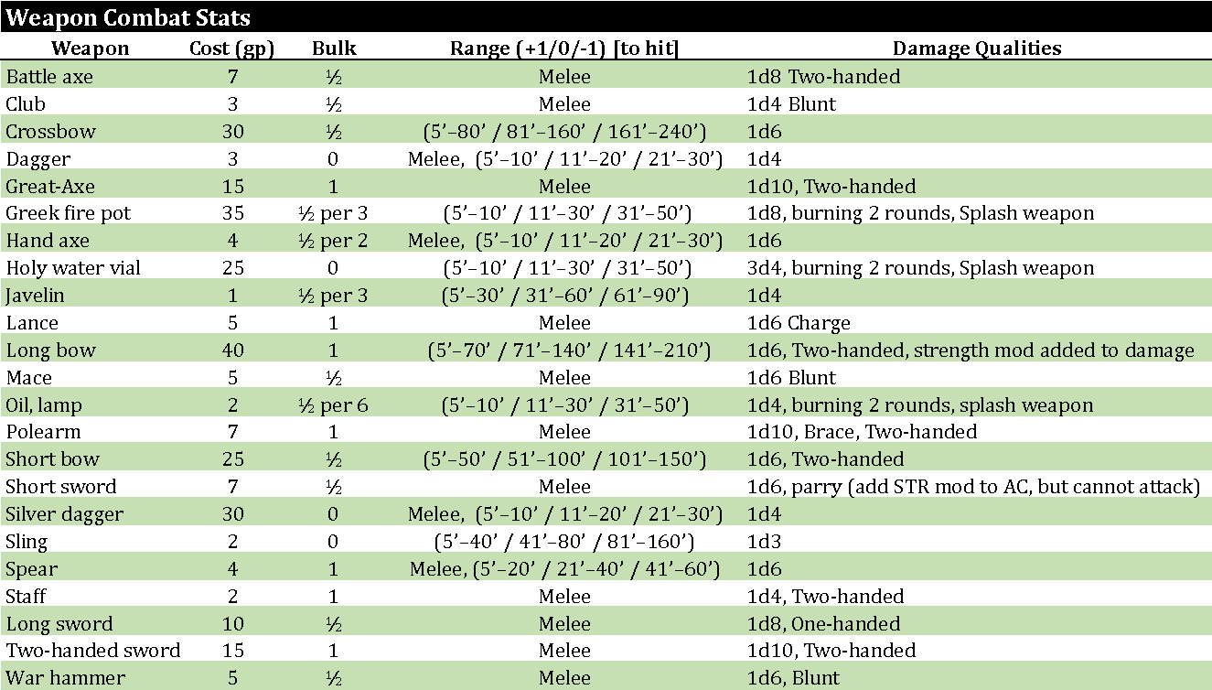

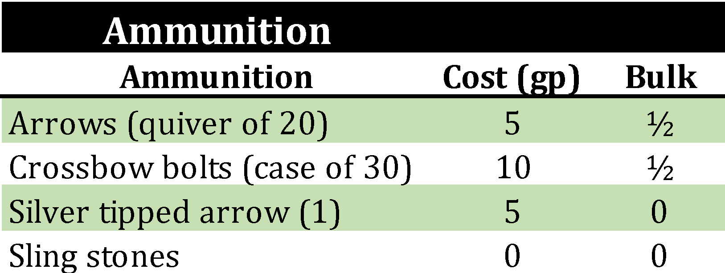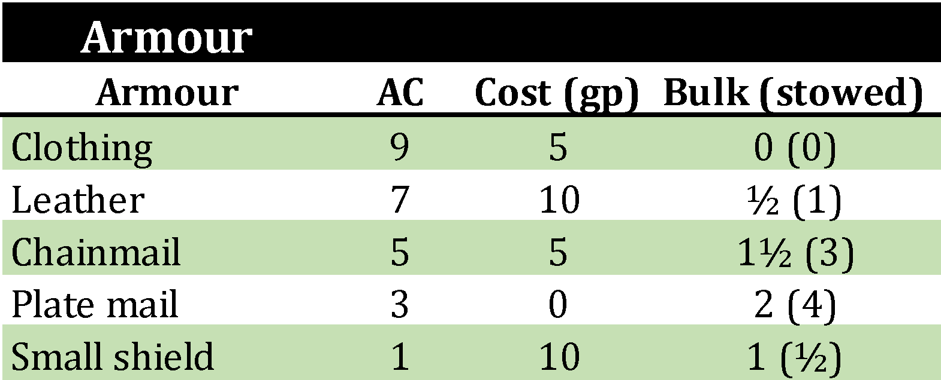

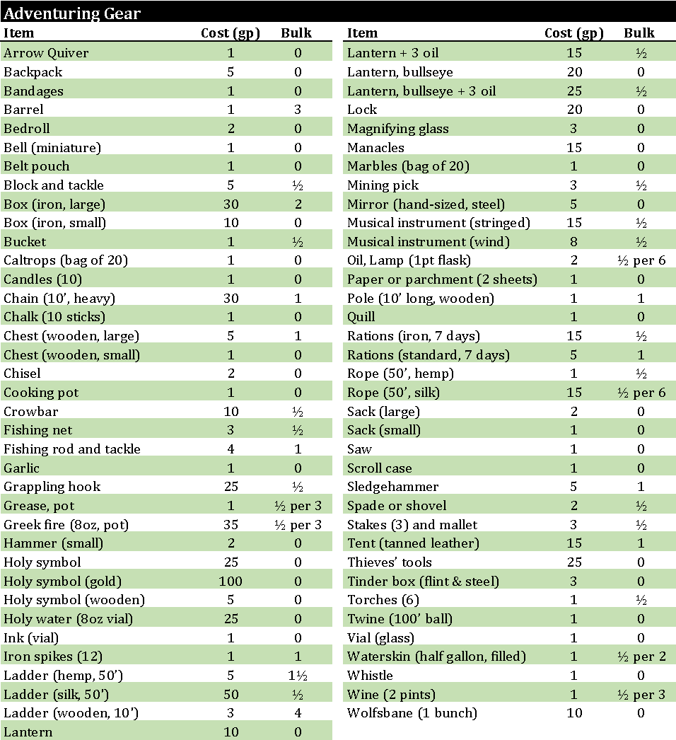

# **------------------------------------------DOWNTIME ACTIVITIES---------------------------------------------**

# Additional Weapon Proficiency Training

